2nd International Symposium for Young Researchers in Biology
(May 10 – 13, 2018, Hammamet, Tunisia) Dar Sébastien-Centre Culturel International

Name: (Please write your name as you want to find it in the final certificate)
Institution:
Research field:
Address:
Tel:
Email:

Participation: (Please delete the non convenient)
Poster Presentation
Oral Presentation
Attendance

Session: (Please delete the non convenient)
Biotechnology
Genomics/Bioinformatics
Bio. Cel/Mol and Immuno

Payment: (Please delete the non convenient)
Cash
Bank Check
Bank Transfer

Registration fees (4 symposium days: 10, 11, 12 and 13 May 2018)

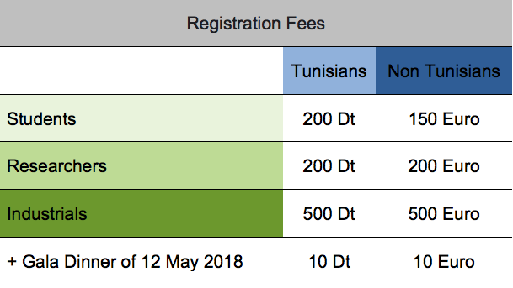

PS1: Symposium fees include attendance to all scientific sessions and conferences, organized meeting and network with the invited speakers, refreshments (2 coffee breaks/day), lunch bag, the YTRB bag containing the final program in USB key, the symposium book and the certificate of attendance. (No accommodation).

PS2: For the accommodation, participants will find a multitude of Hotels, Motels and Residency just next to the conference place. We negotiated preferential prices with the “Les Citroniers bed & Breakfast” and the “La Paix” (5 min by walk to the conference venue) for our participants with a prices starting from 30 Dt in a triple room to 40 Dt for a single room.

PS3: We kindly inform our participants that we don’t accept the “Bon de Command”. However we can guarantee all the documentations needed allowing you the reimbursement of fees from your institutions.

The Organizing Committee,

